IT 2110 – Android Mobile App Development   
**Lab 02 -** **Intents**

**Description:**

In this lab, you will use both implicit and explicit intents to open another Activity from the Main Activity in Android. You should display your work by adding screenshots to this Word Document. When complete, upload your Word document to Blackboard.

**Instructions:**

1. Use the following tutorial to create an application that opens a second Activity (10 points).

<http://developer.android.com/training/basics/firstapp/starting-activity.html>

1. Add a button to the first Activity that uses an implicit (Common) Intent to start another action (10 points).

<http://developer.android.com/guide/components/intents-common.html>

**Deliverables:**

Insert screenshots in this document after each question by taking screenshots of your editor window and the app running on your computer. Submit the completed document to Lab02 Dropbox.

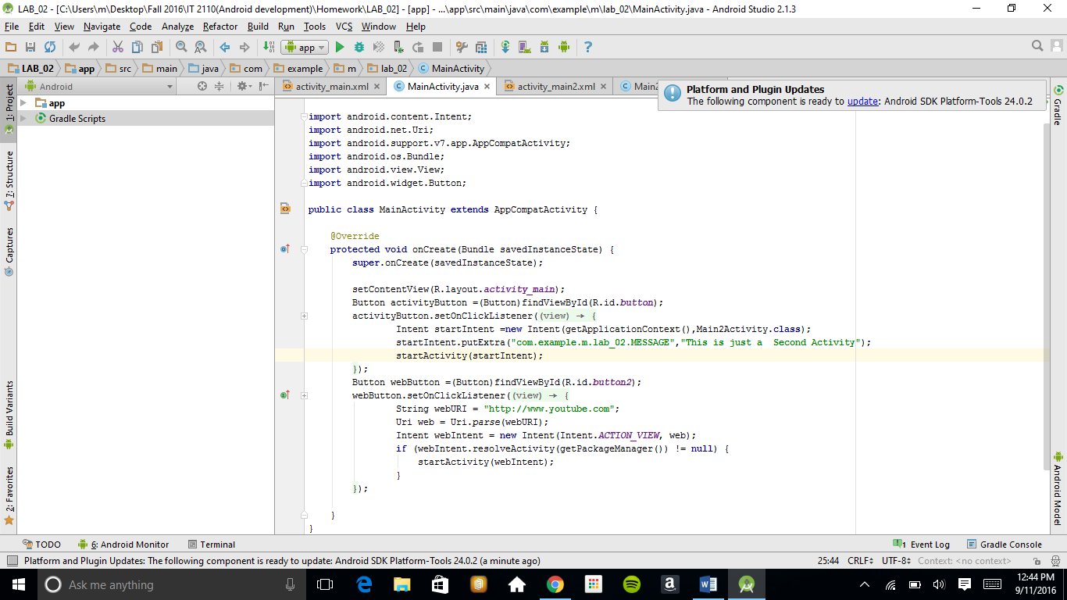

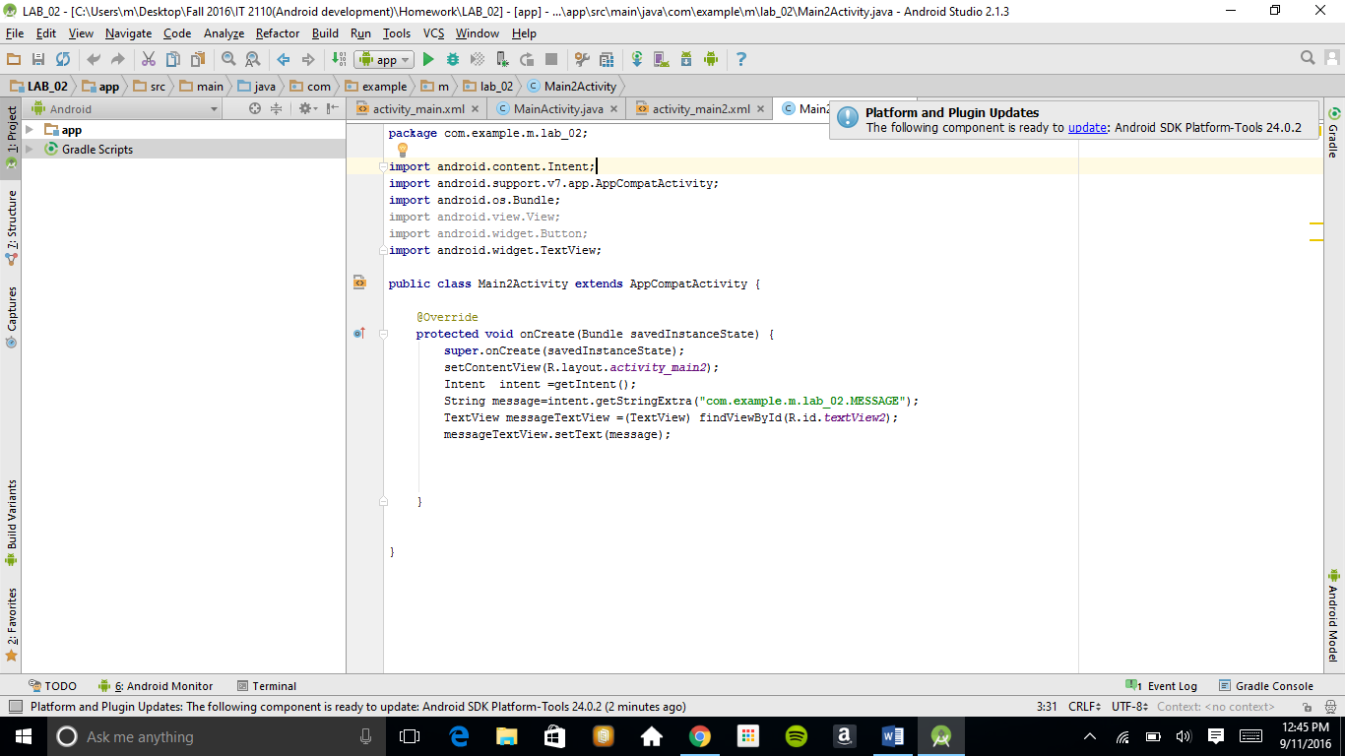

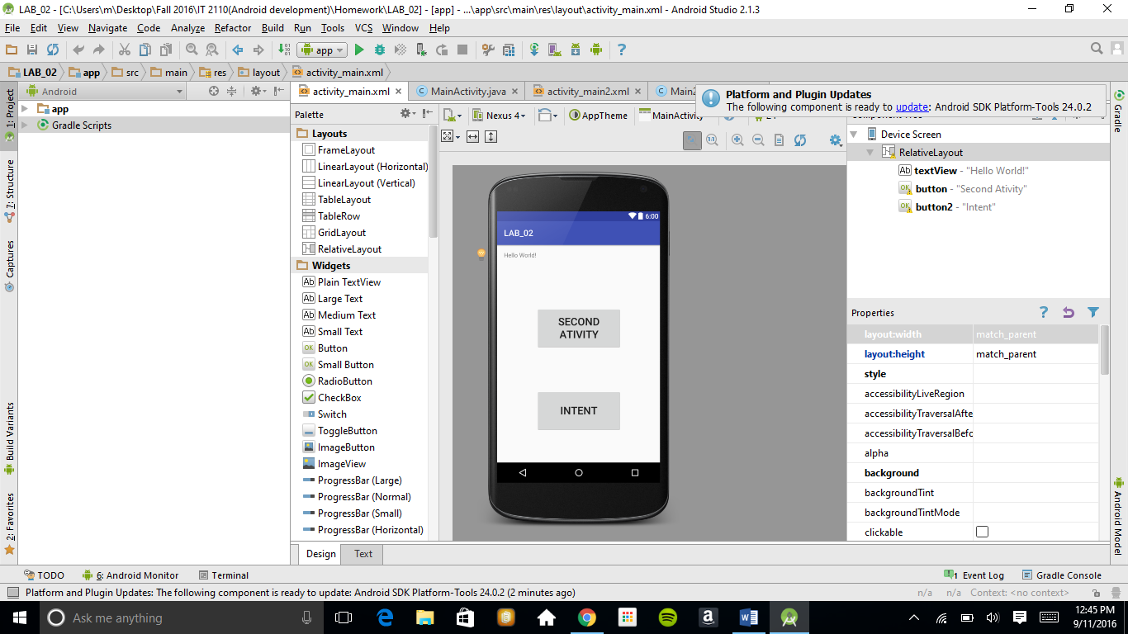

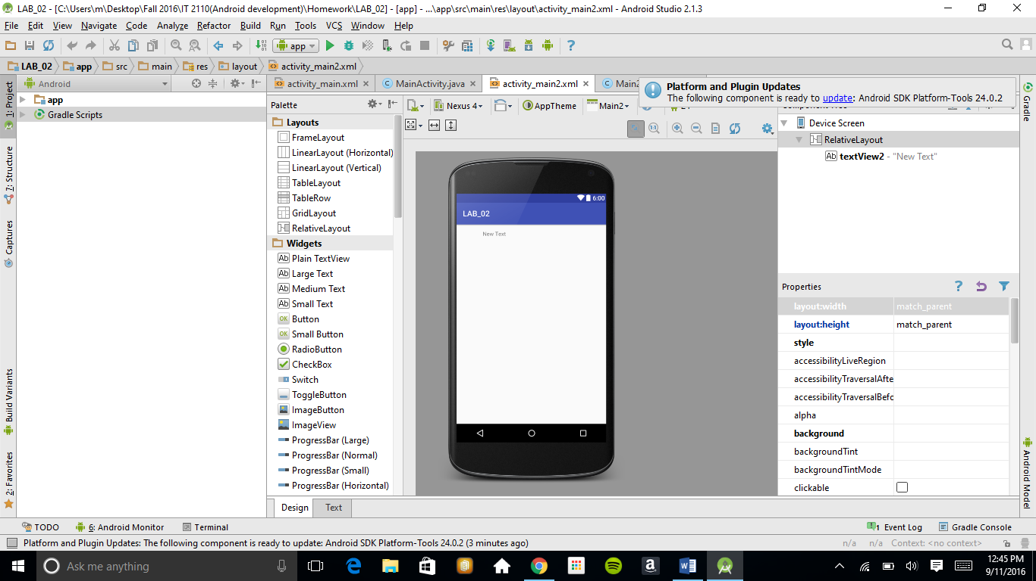

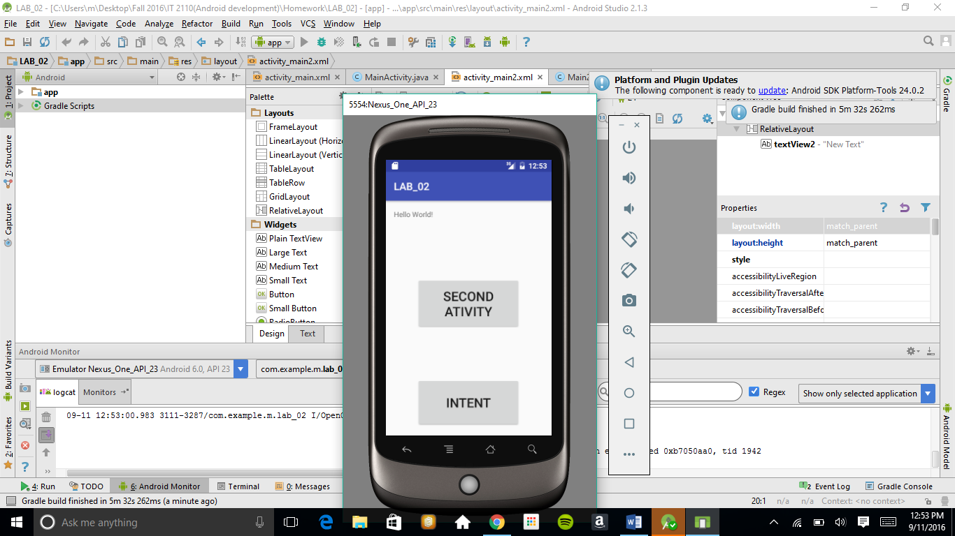

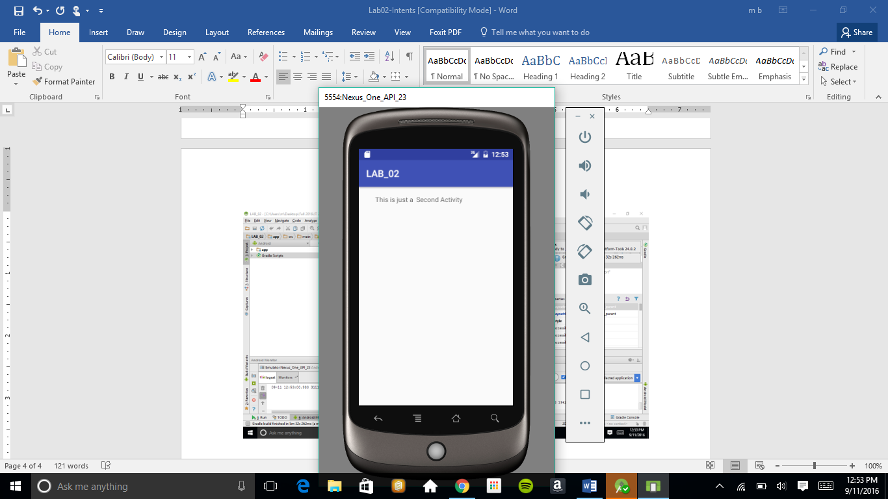

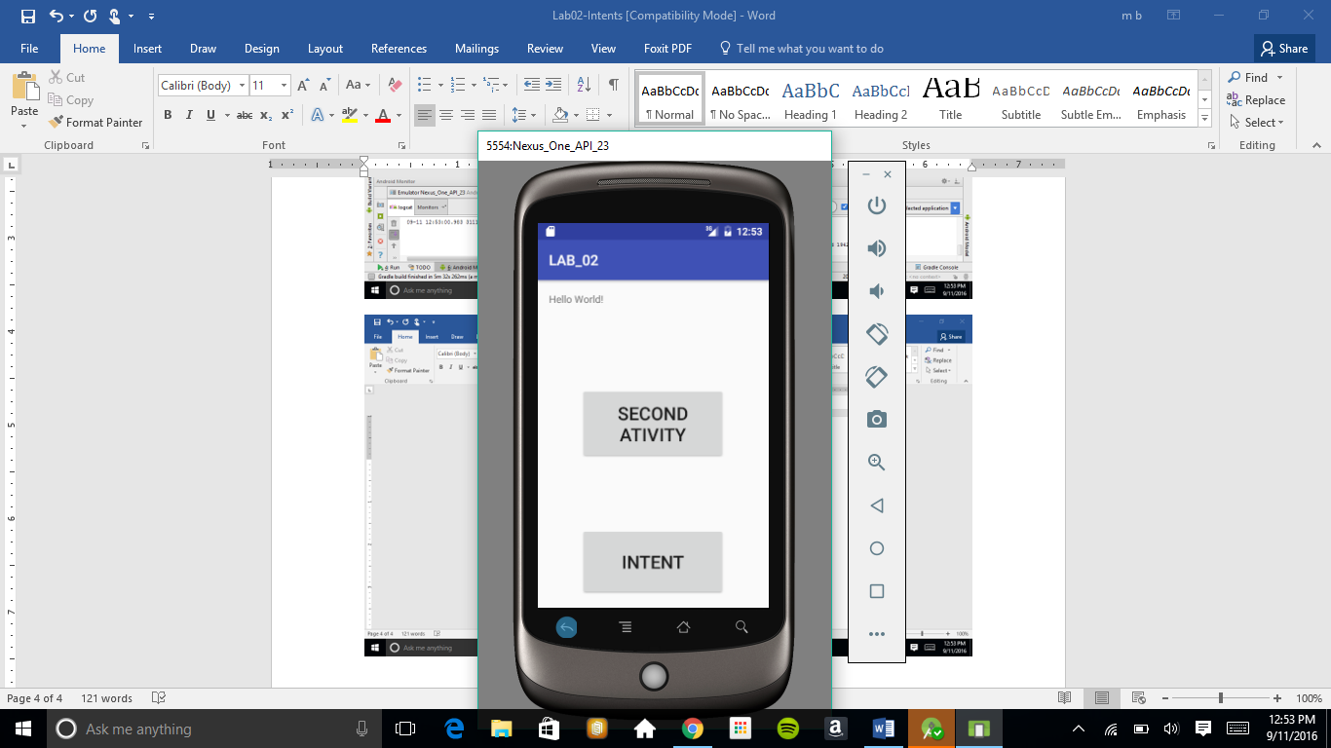

I set up for intent to open Youtube web page

